VELLORE INSTITUTE OF TECHNOLOGY



OSTutorLLM

YUVANESH.R GAUTHAM.G
24BCE2487 24BCE2148

Table of Contents:

Chapter | Contents | Page No.
1 | Introduction | 1
1.1 | Project Overview | 1
1.2 | Educational Context and Motivation | 2
1.3 | Scope and Contribution | 3
2 | Literature Review | 4
2.1 | Retrieval Augmented Generation | 4
2.2 | Sentence Embeddings and Compact Encoders | 5
2.3 | Lexical Retrieval and Rank Fusion | 6
2.4 | Open Language Models and Inference Efficiency | 7
2.5 | Educational Tools and the Project Gap | 8
3 | Problem Statement | 9
3.1 | Formal Problem Definition | 9
3.2 | Requirements and Operating Constraints | 10
4 | Objectives | 11
4.1 | Aim and Specific Objectives | 11
4.2 | Objective Traceability and Acceptance | 12
5 | Methodology | 13
5.1 | Overall System Architecture | 13
5.2 | Software Environment and Module Structure | 14
5.3 | Document Acquisition and Extraction | 15
5.4 | Chunk Construction and Source Identity | 16
5.5 | Embeddings and Vector Index Construction | 17
5.6 | Hybrid Search and Candidate Selection | 18
5.7 | Context Construction and Answer Safeguards | 19
5.8 | Language Model Loading and Generation | 20
5.9 | Learning Modes and Answer Presentation | 21
5.10 | Structured MCQ Generation | 22
5.11 | MCQ Validation and Quality Control | 23
5.12 | Quiz Storage and Transactional Grading | 24
5.13 | Rule Based Difficulty Adaptation | 25
5.14 | Scheduling Service and Input Model | 26
5.15 | FCFS and Non Preemptive SJF | 27
5.16 | Round Robin and Boundary Conventions | 28
5.17 | Browser Interface and Callback Flow | 29
5.18 | Deployment Persistence and Repeatability | 30
6 | Results and Discussions | 31
6.1 | Evidence Categories and Reporting Scope | 31
6.2 | FCFS Worked Example | 32
6.3 | Non Preemptive SJF Worked Example | 33
6.4 | Round Robin Worked Example | 34
6.5 | Comparative Interpretation of Schedules | 35
6.6 | Boundary and Validation Cases | 36
6.7 | Backend Regression Results | 37
6.8 | Retrieval and Answer Review | 38
6.9 | Practice and Progress Review | 39
6.10 | Discussion of Outcomes and Evidence | 40
7 | Conclusions | 41
7.1 | Project Conclusions and Repository Details | 41
8 | Limitations | 42
8.1 | Knowledge Coverage and Generation Quality | 42
8.2 | Runtime Security and Numerical Scope | 43
9 | Future Work | 44
9.1 | Retrieval and Assessment Improvements | 44
9.2 | Deployment and Learning Experience | 45
— | References | 46–47

1 Introduction

1 1 Project overview
OSTutorLLM is a browser-based learning application for Operating Systems that brings together course-document retrieval, a pretrained language model, adaptive practice and a CPU scheduling calculator. The project tackles an academic need: a student should be able to ask an OS question view the relevant teaching material and practice the concept all in one place without having to switch between many unrelated tools. The main design choice is to keep the evidence that supports an explanation to the learner.
The application uses Qwen3-4B for text generation and all-MiniLM-L6-v2 for document embeddings. Chroma keeps the representations while BM25 supplies keyword rankings. A Gradio interface shows the tutor, quiz and scheduling functions through three tabs. SQLite logs practice attempts for each student pseudonym and topic. The reference execution environment is a Google Colab session where project documents and progress are stored in Google Drive.
The implementation is built around an existing language model. The team does not claim to have pretrained a foundation model or performed instruction fine-tuning. The original proposal considered models and optional tuning but the implemented scope uses a smaller quantized model and direct Python library calls. This keeps the system understandable and feasible for a course prototype while still retaining a generative component.
The report follows the project from its motivation to the implemented algorithms reproducible numerical examples, backend checks, limitations and possible extensions. The main outcome is a working application design where generated explanations can be inspected against retrieved material and where scheduling arithmetic can be verified independently of the language model.

1 2 Educational context and motivation
Operating Systems links ideas with observable execution behaviour. A process state diagram is easier to understand when it is linked to CPU allocation and a scheduling formula is easier to apply when its waiting intervalsre visible. Students however often encounter these topics through lecture slides, notes, manuals and handwritten solutions. Finding the passage and confirming that a worked answer follows the same assumptions can take up a large part of study time.
A course-aware tutor can make these resources more accessible. Accessibility should not be confused with authority. A fluent explanation may overlook an arrival time mix a page with a frame or describe a scheduling variant that's different from the one requested. The educational value therefore depends on linking an answer to evidence and on making the assumptions of a numerical solution explicit. The system treats source display as a learning aid than as proof that every sentence is correct.
The chosen subject also offers a division of responsibilities. Language generation is suitable for explanations, comparisons and question wording. Deterministic algorithms are more suitable for producing completion and waiting times under a defined scheduling model. Combining these two capabilities creates a demonstration where the learner can move from an explanation to a table and an execution chart.
The project supports self-paced revision, laboratory preparation and viva practice. It is intended to complement faculty teaching and original learning resources. It has not been evaluated as a replacement for instruction. Has a controlled study established improvements in examination scores or conceptual understanding. Those educational outcomes require a study with consented participants and a defined assessment method.

1 3. Contribution
The scope is a controlled prototype that covers the OS topics represented in uploaded files. Supported input formats are text-bearing PDF, PPTX, TXT and Markdown. The code defines topic choices for processes and threads CPU scheduling, synchronization, deadlocks, memory management, file systems and Linux and shell. A topic being present in the menu does not mean that the uploaded corpus actually contains material for it.
The main contribution is the integration of source-aware answering, question generation saved practice history and exact scheduling computation in a single interface. The retriever preserves document identity and page or slide position. The tutor exposes four answer styles. The practice service validates generated question structure and blocks repeated grading of the question. The calculator implements three scheduling algorithms. Visualizes their execution intervals.
Several boundaries remain deliberate. Each question is handled independently; the tutor does not maintain memory. The application does not execute generated shell code. Student pseudonyms progress records but are not individual authenticated accounts. The current public interface is a tunnel to the active Colab process rather, than an independently deployed institutional service.
The work can be seen as software integration, algorithm implementation and transparent demonstration. The distinctiveness of this work comes from linking explanations to an OS laboratory exercise rather than claiming a new retrieval algorithm or language-model architecture. This clear difference helps guide the literature review and stops the implementation results from being taken as research or claims about learning effectiveness.

1 Introduction

1 1 Project overview
OSTutorLLM is a browser-based learning application for Operating Systems that brings together course-document retrieval, a pretrained language model, adaptive practice and a CPU scheduling calculator. The project tackles an academic need: a student should be able to ask an OS question look at relevant teaching material and then practise the concept without moving between several unrelated tools. The main design choice of OSTutorLLM is to keep the evidence used for an explanation to the learner.
OSTutorLLM uses Qwen3-4B for text generation and all-MiniLM-L6-v2 for document embeddings. Chroma keeps the representations while BM25 adds keyword rankings. A Gradio interface shows the tutor, quiz and scheduling functions in three tabs. SQLite stores practice attempts for a student pseudonym and topic. The reference environment for running OSTutorLLM is a Google Colab session with project documents and progress saved in Google Drive.
The implementation of OSTutorLLM is an integration around an existing language model. The team does not claim that OSTutorLLM has pretrained a foundation model or performed instruction fine-tuning. The original proposal looked at models and optional tuning but the scope that OSTutorLLM now delivers uses a smaller quantized model and direct Python library calls. This approach keeps OSTutorLLM understandable and feasible for a course prototype while still keeping a generative component.
The report follows OSTutorLLM from its motivation to the implemented algorithms reproducible numerical examples, backend checks, limitations and possible extensions. The main result of OSTutorLLM is a working application design where generated explanations can be inspected against retrieved material and where scheduling arithmetic can be verified separately from the language model.

1 2 Context and motivation
Operating Systems links abstract ideas to observable execution behaviour. A process state diagram becomes clearer when it is tied to CPU allocation and a scheduling formula is easier to use when its waiting intervals are visible. Students still often meet these topics through lecture slides, notes, manuals and handwritten solutions. Searching for the passage and checking that a worked answer follows the same assumptions can take a large part of study time.
A course-aware tutor can make these resources easier to reach. Easier access does not equal authority. A fluent explanation from OSTutorLLM might miss an arrival time mix up a page with a frame or describe a scheduling variant that's different from the one asked for. The educational value of OSTutorLLM therefore depends on linking an answer to evidence and on making the assumptions of a numerical solution clear. OSTutorLLM treats source display as a learning aid of proof that every sentence is correct.
The chosen subject also gives a split of responsibilities. Language generation is good for explanations, comparisons and question wording. Deterministic algorithms are better for giving completion and waiting times under a defined scheduling model. When OSTutorLLM combines these two abilities it creates a demonstration where the learner can move from an explanation to a table and to an execution chart.
OSTutorLLM supports self-paced revision, laboratory preparation and viva practice. It is meant to complement faculty teaching and original learning resources. OSTutorLLM has not been tested as a replacement for instruction. No controlled study has shown improvements in exam scores or conceptual understanding. Those educational results need a study with consented participants and a defined assessment method.

1 3 Scope and contribution
The scope of OSTutorLLM is a controlled prototype that covers the OS topics found in uploaded files. Supported input formats include text-bearing PDF, PPTX, TXT and Markdown. The code lists topic choices for processes and threads CPU scheduling, synchronization, deadlocks, memory management, file systems, Linux and shell. The presence of a topic, in the OSTutorLLM menu does not guarantee that the uploaded corpus actually contains material for that topic.
The main contribution of OSTutorLLM is the integration of source-aware answering, structured question generation saved practice history and exact scheduling computation into an interface. The retriever keeps document identity and page or slide position. The tutor shows four answer styles. The practice service checks the structure of generated questions. Stops repeated grading of the same question. The calculator runs three scheduling algorithms. Shows their execution intervals.
Several boundaries remain deliberate. Each question is handled independently and I see that the tutor does not keep memory. The application does not run generated shell code. Student pseudonyms separate progress records,. I note that they are not individual authenticated accounts. The current public interface is a tunnel to the active Colab process and I see that it is not an independently deployed institutional service.
The work can be assessed as software integration, algorithm implementation and transparent demonstration. Its distinctiveness lies in linking explanations, to an OS laboratory exercise and I see that it does not claim a new retrieval algorithm or language-model architecture. This distinction guides the literature review. Prevents the implementation results from being interpreted as unsupported research or learning-effectiveness claims.

2 Literature Review

2 5 Educational tools and the project gap
Operating Systems teaching resources commonly organize the subject around mechanisms such as scheduling, memory, concurrency and persistence. Operating Systems Three Easy Pieces is one reference for connecting such concepts with practical exercises [10]. The project uses this framing to explain why a numerical laboratory complements a text-based tutor; it does not claim to have indexed that textbook unless the team actually adds permitted copies to the corpus.
Approach | Useful capability | Gap addressed here
Static teaching files | Faculty material and traceable pages | Interactive retrieval and explanation
General language model | Flexible natural-language response | Explicit course-document context
Scheduling calculator | Repeatable numerical calculation | Connection to explanations and practice
OSTutorLLM prototype | Retrieval, practice and scheduling | Quality and deployment evaluation remain

Different tools serve different parts of the learning workflow. Static notes preserve faculty wording general language models offer flexible explanation and scheduling calculators give numerical output. OSTutorLLM integrates these roles around course documents. Its question-generation and progress features add practice while its deterministic calculator provides a check on arithmetic.
The comparison is architectural than a controlled product benchmark. It identifies which functions the implemented prototype combines. The project has not demonstrated that its answers outperform assistants, nor that its difficulty rule improves learning. Those conclusions would require matched tasks, participant studies and a complete experimental design.

3 Problem Statement

3 1 Formal problem definition
The problem is to design and implement an academic OS tutor that answers student questions using supplied course material supports practice and provides a verifiable numerical exercise. A successful implementation must connect language generation to retrieval rather than stopping at a list of similar text chunks. It must also preserve source information for a learner or faculty member to inspect the basis of an explanation.
For each student question the system receives natural-language text and a selected answer style. It must identify chunks from the current corpus determine whether any meet a configured relevance gate construct bounded context and ask a pretrained model to respond. When no evidence passes the gate it must return an insufficient-support message without calling the generator. This is a control-flow requirement although it is not a guarantee of perfect out-of-scope detection.
For practice the system must generate one four-option MCQ validate its structure save its answer key and accept at one graded submission. It must associate attempts with the selected pseudonym and topic. The requested difficulty must be derived from a rule that can be explained during an academic review. Generated answer keys require checking because format validation alone cannot establish substantive correctness.
For CPU scheduling the input is a set of uniquely named processes with arrival and burst times. The system must compute an execution timeline and process metrics for non-preemptive SJF and Round Robin under stated assumptions. Exact numerical results are produced by code while the language model can explain the concepts using the course notes.

3 2 Requirements and operating constraints
The interface should expose the system without requiring students to execute notebook cells. At the time a faculty reviewer should be able to trace each function to a visible code module. The prototype therefore uses a Python backend and a Gradio browser application instead of a separate frontend framework, API gateway and model server.
Requirement class | Implementation requirement
Functionality | Grounded answers, practice, progress and scheduling
Traceability | Document path and page or slide per chunk
Integrity | Validated quiz structure and one graded submission
Usability | Three browser tabs and visible errors
Scope | No shell execution or foundation-model training
Recovery | Saved source files, progress and environment records

The corpus is limited to permitted teaching files. A file appearing in Drive is not sufficient: it must yield text and useful chunks. Encrypted, malformed or image- material needs special handling or a checked transcript. Source names and one-based page or slide numbers must remain stable so that the displayed evidence is interpretable.
Operational constraints include Colab resources, a single active notebook writer for progress data, model-download access and temporary runtime storage. The active Chroma database is local to Colab; saved teaching files and chunks can be used to rebuild it. The public link depends on the running backend. These constraints influence recovery. Rule out claims of permanent or fully offline hosting.

4 Objectives

4 1 Aim and specific objectives
The aim is to develop a working OS learning application that combines retrieved course evidence with an existing model and an interactive scheduling laboratory. The objectives translate this aim into software behaviour that can be inspected and tested. They concern implementation and observable outputs; claims about learning improvement require evidence beyond a functioning prototype.
The first objective is to make uploaded documents searchable while preserving their identity. This requires extraction, chunking, embeddings and index construction. The second objective is to connect retrieval to answer generation with clear separation between the embedding model and the language model. Source labels and an evidence panel support checking of the resulting explanations.
The third objective is to provide learning modes: simple explanation, exam-style response, viva practice and a shell exercise. The fourth is to create MCQs and save topic-wise attempts. The fifth is to request difficulty using a recent-performance rule rather than using an unexplained personalization label.
The sixth objective is to implement scheduling calculations and a chart for three algorithms. The seventh is to make the prototype repeatable through a self-contained notebook, explicit dependencies and regression checks. Together these objectives provide an academic submission scope while identifying the testing, security and deployment work still needed for broader use.
• Course-document retrieval with page- evidence.
• Pretrained model inference connected to retrieved context.
• Practice generation with structure and saved attempts.
• Python-computed schedules with assumptions.

4 2 Objective traceability and acceptance
Each objective should have an acceptance condition. For example "use RAG" is too broad to verify by itself; an assessor should be able to submit a question inspect retrieved excerpts and compare the cited location with the source. Similarly "adaptive" should be supported by a rule and stored attempts rather than a changing difficulty label alone.
Objective | Acceptance evidence
Readable corpus | Extraction report and meaningful chunk preview
Connected generation | Qwen answer produced after retrieval
Evidence display | Source filename and page or slide shown
MCQ integrity | Four distinct options and a valid stored key
Progress tracking | Attempts remain after Tutor recreation
Difficulty rule | Known attempts produce the documented level
Scheduling correctness | Tables match independent arithmetic
Repeatability | Notebook, package list and test output retained

Acceptance evidence must also be interpreted at the right level. A visible answer establishes that the pipeline executed, not that all claims are supported. A passing unit test establishes behaviour for its inputs and dependencies not end-to-end generation quality. The results chapter distinguishes checks, implementation inspection and the additional evidence needed for formal retrieval or educational evaluation.
The objectives are achievable without tuning because the desired behaviour can be assembled through retrieval, prompt instructions, validation and application code. If a later assessment specifically requires changed model weights that would be a requirement. The current report therefore describes the implementation rather than treating optional proposal features as completed work.

5 Methodology

5 1 Overall system architecture
The architecture separates preparation from interaction. During preparation the system extracts documents creates source-bearing chunks and indexes their embeddings. During interaction a question is encoded candidate passages are. Ranked and selected context is passed to the generator. Gradio displays the answer and evidence. Practice and scheduling are application services that share the interface but maintain their own validation rules.
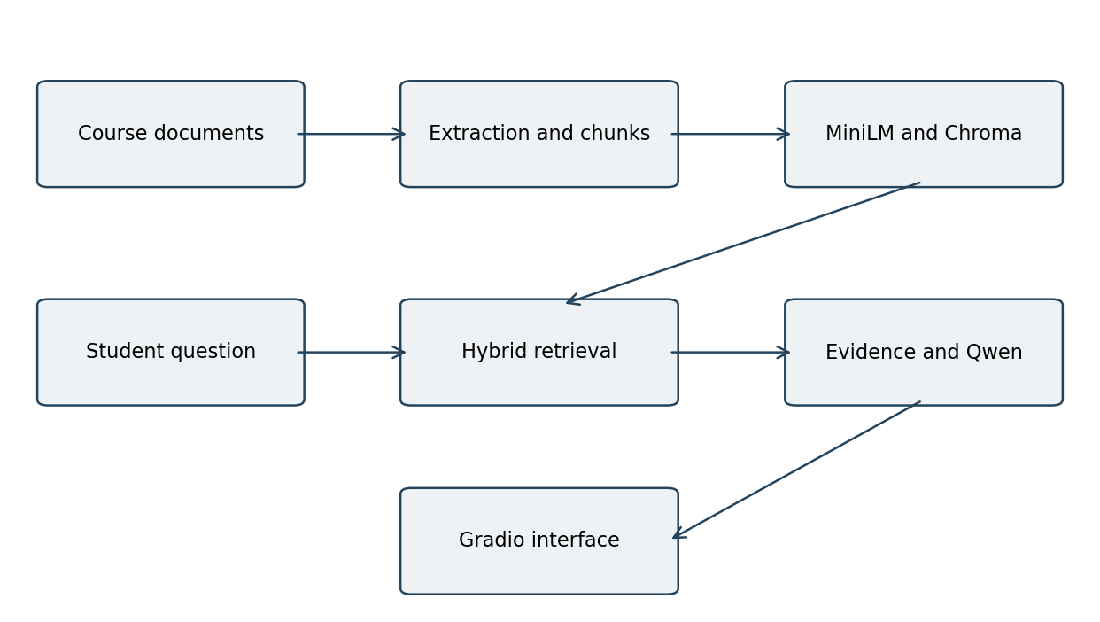
Figure 5 1 Preparation and question answering architecture
This division prevents computation from being hidden inside a language-model prompt. It also allows the retriever and quiz service to be tested with substitutes. The model interface is a generate function, which the Tutor receives as a dependency. That design makes it possible to check abstention and grading without downloading Qwen.
The diagram shows the retrieval path. SQLite stores quiz state, outside this flow and the scheduling service directly calculates timelines from user input. The same model is used for explanation and question wording; the implementation does not route between language models.

5 2 Software environment and module structure
The system is built around three parts: core.py, ui.py and the Colab notebook. The backend holds functions and service classes. The interface creates widgets. Links them to callback functions. The notebook handles dependency installation mounts project storage writes modules, loads models creates service objects and starts the demonstration. The guide explains how everything works in sequence.
Component | Reference configuration
Language model | Qwen/Qwen3-4B
Embedding model | all-MiniLM-L6-v2 on CPU
Model runtime | Transformers 4.56.2 with bitsandbytes 0.48.1
Vector store | Chroma 1.1.1 with cosine space
Interface | Gradio 5.49.1
Parsing | pypdf 6.1.1 and python-pptx 1.0.2
Practice storage | SQLite through Python sqlite3
Visualization | pandas tables and Matplotlib charts
Version pins refer to the provided dependency file, not the exact packages in every Colab environment. The working runtime should preserve the output of pip freeze. A CUDA-enabled PyTorch installation is already available in the runtime. Should not be replaced without care. Compatibility checks are important because preinstalled packages may have requirements.
The notebook includes all cells for writing modules so it is self-contained. Still uploaded standalone modules are the way to see how things currently work. Source control must track any fixes made during the demo so that the notebook and modules don’t drift unnoticed.

5 3 Document acquisition and extraction
Documents go into the project course directory. Are found recursively. Only files with PDF, PPTX, TXT or Markdown extensions are accepted. The ingestion function separates file-level extraction errors. Logs them in a report instead of treating every uploaded file as usable. At one meaningful chunk must be created before the pipeline continues.
for n, page in enumerate(PdfReader(str(path)).pages, 1):
yield n, clean(page.extract_text() or '')
# PPTX branch keeps one-based slide numbers and
# reads text, tables, groups and speaker notes.
PDF extraction goes through pages starting at one. Uses pypdf to extract text. PPTX extraction goes through slides. Reads text frames, table cells grouped shapes and speaker notes when available. Text and Markdown files are treated as single source units. The parser removes characters and normalizes horizontal whitespace but does not try to interpret diagrams or visual reading order.
Keeping pages. Slides separate helps with evidence inspection. A student can find the source unit without scanning through the presentation.. Text from a slide may lose meaning that comes from arrows or layout. So a source location shows where the words came from but does not guarantee that the full meaning was captured.
Images with no text are not handled by the parser. OCR or manual checking must be done before using files. The extraction report records character counts and chunk counts so that empty or very small files can be checked before retrieval testing.

5 4 Chunk construction and source identity
The ingestion function breaks each source unit into windows of up to 140 words moving forward by 115 words each time. Adjacent full windows overlap by 25 words. Source units and leftover fragments with than eight words are discarded. These choices keep context and reduce isolated labels but they can also miss a short definition. These settings should be reviewed against the teaching material.
for start in range(0, len(words), 115):
chunk = ' '.join(words[start:start + 140])
key = hashlib.sha256(
f'{source}|{page}|{start}|{chunk}'.encode()
).hexdigest()
A chunk record includes text, relative source path, page or slide number and a SHA-256 identifier. The identifier uses the source, position, window start and content. Changed text gets an identifier. A per-file seen set prevents repeats of the same page and text within one ingestion pass. It is not a deduplication system across all documents.
The extracted corpus is saved as JSON through a file and then replaced. This reduces the chance of having a JSON file during a normal write. It is not a transaction that spans all Drive files or all indexing steps. Keeping the teaching files is still essential for recovery.
The window length is measured in words, not tokens. Technical symbols and identifiers may tokenize in ways. A future token-aware splitter could give control over truncation without changing the source metadata scheme.

5 5 Embeddings and vector index construction
Retriever initialization loads all-MiniLM-L6-v2 on CPU. Produces normalized embeddings for batches of chunks. Each vector is stored with the chunk ID, document text and metadata. The same encoder makes the question vector at search time. Using encoders without rebuilding the index would cause inconsistent similarity comparisons so the encoder name is part of the collection signature.
self.collection = self.client.get_or_create_collection(
'os_' + signature,
configuration={'hnsw': {'space': 'cosine'}}
)
embeddings = self.encoder.encode(
texts, normalize_embeddings=True
).tolist()
Chroma is set up with PersistentClient and a local cache directory. The collection uses cosine space. A signature based on the encoder name and sorted chunk identifiers tells the corpus from older versions. When files change the new collection is used of looking for stale records. Upserts in batches of 128 let an interrupted indexing attempt be repaired by repeating initialization.
Disk-backed persistence has a limit: the cache survives application restarts on the same disk but can disappear after a complete Colab reset. The project keeps source documents and chunks in Drive. Rebuilds the local index when needed. Copying a database directly into synchronized storage is not included in the backup plan.
The index allows searches but no scaling benefits are assumed from this setup. Index build time and retrieval latency must be tested on the corpus and device before claiming performance improvements.

5 6 Hybrid search and candidate selection
A question first makes an embedding. Chroma returns up to twelve neighbors or fewer if the corpus is small. Cosine distance becomes similarity by subtracting it from one. Candidates below the threshold are removed from the list. The default threshold is 0.32. It acts as a relevance gate, not a probability of correctness.
for rank, cid in enumerate(order, 1):
ranks[cid] = ranks.get(cid, 0) + 1 / (60 + rank)
chosen = sorted(
valid, key=lambda cid: ranks.get(cid, 0),
reverse=True
)[:k]
BM25 scores the question against every chunk. The code keeps most twelve chunks with positive scores. The lexical and dense rankings both contribute reciprocal-rank values to a shared score map. A candidate in both lists gets two scores. The eligible dense candidates are sorted by combined score and up to four are returned.
Because valid includes dense neighbors above the threshold the lexical stage reranks a shortlist instead of expanding it without control. A rare exact term may still be missed if it is not in that list. This is an area for future retrieval testing.
Threshold selection should use a development subset with both supported and unsupported questions. Choosing the threshold on the test set would make performance seem better than it is. The current setting is described honestly not as an optimized version.

5 7 Context construction and answer safeguards
Selected excerpts are grouped into context blocks labeled with one-based source IDs. Each block includes the source path, page or slide number and text. The question is added separately. The system prompt asks for answers based on evidence. Tells the model to treat study material as data not as instructions.
if not hits:
return ('I could not find enough support in the '
'uploaded course material. Upload the '
'relevant notes or rephrase the question.',
'', status)
# Generation occurs only after this branch.
Before retrieval the tutor checks for questions and questions longer than 1,800 characters. If search returns no evidence it answers with an insufficient-support message and never calls the generator. This explicit check can be tested with a generator that would fail if used. It does not prove that every unsupported question will return no results.
After generation the code checks numeric citation labels. An out-of-range ID replaces the answer with an error message. If no numeric citation appears a warning is added. These checks check reference syntax and range. Do not verify whether the cited part actually supports the claim.
The evidence panel shows the text sent to the model so a learner can check for missing pieces or misleading matches. Source transparency and answer correctness are quality traits. Both are part of the demo checklist.

5 8 Language model loading and generation
The notebook loads the tokenizer and Qwen3-4B checkpoint using Transformers. The bitsandbytes config sets four-bit NF4 weights, double quantization and float16 computation. The model is placed on CUDA device zero. Set to evaluation mode. These steps prepare the model for inference. Do not update weights.
quantization = BitsAndBytesConfig(
load_in_4bit=True,
bnb_4bit_quant_type='nf4',
bnb_4bit_use_double_quant=True,
bnb_4bit_compute_dtype=torch.float16,
)
# Default answer budget: 750 new tokens.
# Greedy generation: do_sample=False.
# Greedy generation: do_sample=False.
The generate function builds system and user messages. Applies the models chat template with thinking disabled. It tokenizes the prompt checks that input is no longer than 6,000 tokens and moves input tensors to the model device. The output is decoded after removing the input prefix. The result contains only generated text.
A generation lock and inference_mode control GPU. Avoid building gradient state. The UI also limits how many callbacks run, at once. Repetition penalty is set to 1.08. The default answer budget is 750 tokens. Quiz generation uses 650 tokens. These limits keep work manageable. May cut off difficult outputs, especially structured JSON.
The reference target is a GPU runtime than a guaranteed device specification. If memory is insufficient the documented fallback is a model followed by a fresh restart. Any fallback should be recorded in run metadata of presenting results as though the same model was used.

5 9 Learning modes and answer presentation
The tutor offers four answer styles. Explain simply requests a definition, an explanation and a small example. Exam answer requests a response without inventing marks or examination patterns. Viva practice asks for five questions with suggested answers. Shell lab asks for one beginner exercise displayed code, sample input and output and an explanation.
Mode | Output intention | Important boundary
Explain simply | Definition and example | Illustrative examples must be labelled
Exam answer | Organized academic response | No invented marking scheme
Viva practice | Five short questions and answers | Not the separately graded MCQ service
Shell lab | Exercise and displayed script | Generated code is never executed
These modes change instructions to the same generator. They do not select trained models or implement learned topic routing. The retrieved evidence remains the grounding material for all modes. If the corpus lacks material selecting Shell lab does not create factual support for an otherwise unsupported request.
The interface uses Markdown for generated answers and an expandable evidence panel for supporting excerpts. A separate status field exposes elapsed answering time and source count. These values are feedback, not evidence of accuracy. The elapsed time may include generation. Should not be compared with a retrieval-only measurement without qualification.
Each request is independent. A follow-up such, as "why?" is not expanded using conversation history. The student is instructed to repeat the topic, a limitation that keeps context handling simple and explicit.

5 10 MCQ generation
The practice service accepts a student pseudonym and a topic selected from the supported menu. The pseudonym must contain one to forty letters, digits, underscores or hyphens. It retrieves material using a topic query and determines a requested difficulty from saved attempts. If no evidence passes the retrieval gate question creation stops before generation.
{
'question': '...',
'options': ['...', '...', '...', '...'],
'answer_index': 0,
'explanation': '... [1]',
'source_ids': [1]
}
The prompt asks for one MCQ with four distinct options one correct answer, a zero-based answer index, an explanation and a list of supporting source IDs. The model is asked to return JSON. The service extracts the substring between the opening brace and last closing brace and attempts to parse it. This tolerates surrounding text. Cannot repair every malformed or truncated response.
Question generation is retried once when parsing or validation fails. If both attempts fail the service raises a message rather than displaying broken controls. A valid question receives a UUID identifier. Is saved with its pseudonym, topic, requested level and evidence. The browser receives the display question and options while the backend retains the grading payload.
The explanation and correct option are revealed after submission. The architecture therefore separates question display from grading although the shared demonstration login and pseudonym design do not provide institutional assessment security.

5 11 MCQ validation and quality control
The validator checks the shape of the generated object before it is stored. The question and explanation must be strings. Options must be a list of four strings and normalized option text must be distinct. The answer index must be an integer between zero and three. Source IDs must be a list of integers within the supplied evidence range.
Validation | Failure prevented
Four nonempty options | Missing or unusable answer controls
Distinct option text | Obvious duplicate choices
Integer answer index 0 to 3 | Invalid option lookup
Nonempty explanation | Feedback without rationale
Valid source IDs | References outside the retrieved set
The type check deliberately rejects booleans as answer indices even though Python treats booleans as integer subclasses. Source bounds prevent a question from referring to an evidence item that was never retrieved. These are concrete integrity checks that can be exercised without a real language model.
Structural validity is narrower than validity. Two worded choices can both be correct an explanation can contradict its key or all four options can rely on an unsupported premise. The current validator does not solve these problems. Faculty review and sampled manual assessment remain necessary before treating generated questions as an examination bank.
The generators greedy decoding can also repeat a question for the topic and level. The code has no question-history deduplication step. This limitation motivates a question-review workflow rather than an unsupported claim of unlimited unique assessments.

5 12 Quiz storage and transactional grading
SQLite contains two tables. Quiz stores the UUID, student pseudonym, topic, requested level, serialized payload and an answered flag. Attempts stores the pseudonym, topic, correctness indicator and creation time. The schema is small enough to inspect during a review. Supports both progress summaries and recent-attempt queries.
c.execute('BEGIN IMMEDIATE')
# Check quiz ownership, answered flag and choice.
c.execute('UPDATE quiz SET answered=1 WHERE id=?',
(qid,))
c.execute('INSERT INTO attempts VALUES (?,?,?,?)',
(student, topic, int(right), time.time()))
Grading opens a connection. Begins an immediate transaction. It checks that the question exists belongs to the supplied pseudonym and has not already been answered. It validates the chosen display option marks the question answered and inserts one attempt. Successful completion commits both changes; an exception prevents a completed grading operation. This application of transactions is consistent with SQLites documented transaction behaviour [13].
Parameter placeholders are used for SQL values of constructing queries from user text. Duplicate submissions are rejected with a message and do not increase the score. A new Tutor instance can read attempts from the same database path, which separates persistence from the lifetime of a Python object.
A pseudonym match is not authenticated identity. Anyone with the shared demo access can enter another pseudonym. The design is adequate for a controlled demonstration. Should not be used for high-stakes grading without individual authentication and authorization.

5 13 Rule based difficulty adaptation
The level function queries up to the five attempts for one pseudonym and topic ordered by insertion. If than three attempts exist it returns easy. Otherwise it calculates the fraction correct and selects hard at 0.8 or above medium at 0.5 or above and easy below 0.5. The returned value becomes an instruction in the MCQ prompt.

Recent record | Correct fraction | Next requested level
Fewer than three attempts | Not used | Easy
0 of 3 or 1 of 3 | Below 0.5 | Easy
2 of 3 | 0.667 | Medium
3 of 3 | 1.0 | Hard
4 of latest 5 | 0.8 | Hard
2 of latest 5 | 0.4 | Easy
This is a recent-performance heuristic. It is not a trained learner model, a mastery estimate or a calibrated adaptive test. The requested hard level does not prove that the generated question is objectively harder. The rule nevertheless has value because it is understandable, reproducible and easy to demonstrate using a known sequence of attempts.
Progress summaries report all-time total counts for a topic while the next difficulty uses only recent attempts. These values can differ in implication: a student with an overall history may receive an easier next question after recent mistakes. The interface should be interpreted with this distinction in mind.
The code uses insertion order than elapsed time for the window. It does not model time spent answering, forgetting, hints or confidence. Those signals could be added later after deciding what behaviour the adaptation should support.

5 14 Scheduling service and input model
The numerical service accepts plain text rows in the form PID,arrival,burst. It permits one to thirty named processes with nonnegative integer arrival times and positive integer bursts. It limits the burst and maximum arrival to 10,000 for the classroom demonstration. Algorithm selection must match one of the three supported names and the quantum must be positive.
Metric | Definition for this model
Completion | Time when the process finishes
Turnaround | Completion minus arrival
Waiting | Turnaround minus burst
Average metric | Sum of process values divided by process count
The model assumes a single CPU one CPU burst per process no I/O blocking and zero context-switch overhead. Every process eventually completes if its validated burst is finite. These assumptions make the relationship between completion, turnaround and waiting times direct. They also distinguish the exercise from an operating-system scheduler with priorities interrupts, I/O waits and multicore execution.
Processes are sorted by arrival and input order. A pending index tracks arrivals not yet admitted to the queue. A deque holds processes and a dictionary stores remaining execution time. If no process is ready an explicit IDLE interval is. The clock jumps to the next arrival. This event-driven structure avoids iterating through every empty time unit.
The return value contains process records in input order and a timeline in execution order. Keeping those orders distinct makes the table convenient for checking each input process while the chart describes the CPUs sequence.

5 15 FCFS and non preemptive SJF
FCFS removes the process from the ready queue and runs its entire remaining burst. Since the queue is populated in arrival and input order ties are resolved consistently. A process is not interrupted when another process arrives. The implementation records the resulting interval. Admits newly arrived processes before selecting the next process.
if algorithm == 'SJF (non-preemptive)':
p = min(ready, key=lambda p:
(p['burst'], p['arrival'], p['order']))
ready.remove(p)
else:
p = ready.popleft()
run = remaining[p['pid']] # non-preemptive case

Non-preemptive SJF chooses the shortest burst among processes already in the ready queue. Its selection key compares burst, arrival and original input position. Once selected that process runs until completion. A future short process cannot be selected before it arrives and a shorter arrival does not preempt a running process. This is distinct from remaining time first.
With at thirty processes scanning the ready queue for SJF is acceptable for a demonstration. After the sorting FCFS queue operations are linear in the number of processes. The straightforward SJF implementation may perform work in the worst case because it repeatedly scans the queue. No claim of a production-optimized scheduler is made.
These algorithms provide a teaching contrast. Arrival order emphasizes fairness of admission while selecting a ready job can improve waiting time on a particular workload. A single worked example does not establish superiority and does not model starvation under continuously arriving work.

5 16 Round Robin and boundary conventions
Round Robin removes the ready process and executes the smaller of its remaining burst and the time quantum. The clock advances by that amount. Processes that arrived during the interval, including at its ending boundary are admitted before an unfinished running process is returned to the back of the queue. A completed process receives its completion timestamp of being requeued.
run = min(quantum, remaining[p['pid']])
now += run
remaining[p['pid']] -= run
# Admit arrivals with arrival <= now first.
if remaining[p['pid']]:
ready.append(p)
else:
completed[p['pid']] = now
Boundary conventions affect examples with arrivals at a quantum boundary. The implementation explicitly states its convention in the interface. Uses it in the regression test. This avoids treating two ordered charts as contradictory when they actually implement different tie rules. All numerical examples in this report follow the codes convention.
If the sum of rounded-up burst-to-quantum ratios is s the service emits s execution intervals plus any idle intervals. Its runtime and chart complexity therefore depend on the number of slices. Small quanta can create intervals even though the numerical calculation remains straightforward within the input limits.
The calculator does not charge time for switching between processes. In an operating system context-switch overhead changes the trade-off associated with small quanta. The interfaces assumption note prevents the classroom chart from being interpreted as a real-machine execution trace.

5 17 Browser interface and callback flow
Gradio Blocks defines three tabs. Ask your notes contains a question field, answer-style selector, answer display, timing status and expandable evidence section. Adaptive practice contains a pseudonym field, topic menu, question controls, answer choices, feedback and progress. Verify CPU scheduling contains process input, algorithm and quantum selectors a result table, chart and conceptual explanation button.
Callbacks catch backend. Display readable messages rather than exposing a traceback in the main user flow. The interface stores the quiz ID in session state. Grading uses that ID and the current pseudonym to locate the server-side question record. Changing the pseudonym after creating a question correctly prevents submitting it under another name.
The queue uses a default concurrency limit of one and a maximum size of twelve. This is conservative for a GPU demonstration. It does not establish throughput under a class of users. Requests can. A long generation can delay other callbacks. The model lock provides a boundary around generation.
The scheduling explanation button requests a general concept explanation through the tutor then appends exact Python-computed values. It does not send the computed trace for individualized LLM analysis. Thus the explanation is concept-level guidance with verified numbers attached a distinction from claiming that the model reasons, over every scheduling decision.
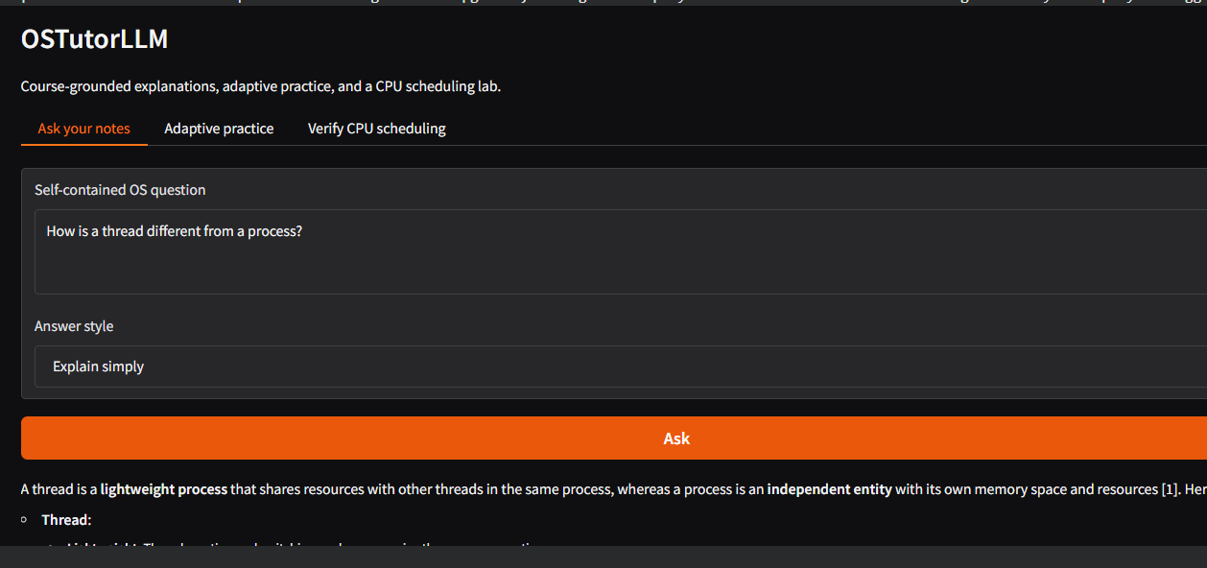Figure 5 2 Browser interface

5 18 Deployment. Repeatability
The notebook mounts Drive and builds a project root, a course folder and a results folder. Runtime modules and the live Chroma index are stored on temporary Colab space. The tutor database lives under the Drive project root. This layout keeps teaching files and practice logs separate from items that can be rebuilt.
Artifact | Storage role
Course files and chunks.json | Durable knowledge-base source
progress.sqlite3 | Durable practice records
Local Chroma cache | Rebuildable runtime index
environment.txt and run_metadata.json | Reproducibility information

The launch cell asks for a demo username and password then starts Gradio with sharing turned on. The public URL forwards traffic to the application [12]. It is a handy review page, not a host. If the runtime is closed or lost the backend stops even though the page address remains known.
After a reset to recover you install dependencies, mount Drive, rewrite modules rebuild the local index load Qwen recreate Tutor and start the UI. Course uploads are skipped unless files have changed. One session should write to the same progress database during a controlled demo. A backup recording helps if GPU quota or network access is uncertain.
The last notebook cell records the pip freeze output and metadata such as model ID embedding model, threshold, chunk count and GPU. These records describe the real execution environment. Aid later troubleshooting. The saved notebook should contain any compatibility fixes used during the run. Credentials and private teaching material must not be committed to a repository.

6 Results and Discussions

6 1 Evidence categories and reporting scope
The built application links document processing, retrieval and language generation through three browser tabs. Functional demos check if the parts work together while numbers and backend checks test rules on their own. Corpus size GPU timing and answer-quality metrics depend on the run and are not guessed from model settings.
Evidence category | Result treatment
Implemented functions | Described from uploaded modules
Scheduling calculations | Recomputed from the supplied function
Backend regression suite | Executed independently for this report
Live generated responses | Add actual screenshots and observations
Formal retrieval metrics | Not reported without labelled cases
Student learning gains | Not established by this prototype
n a live model and chosen teaching documents. Scheduling tables and graphs use the built schedule function. Backend regression checks test service behaviour with controlled inputs. Retrieval and language-model quality need the course corpus, model runtime and questions checked by hand.
This split makes the report defendable in a review. A deterministic graph shows the calculator for a given input. It is not a language-model benchmark. A shown source ID helps traceability. It is not an entailment score. Configuration values in the method stay as settings not as measured performance.

6 2 FCFS worked example
The reference workload contains P1 with arrival zero. Burst five, P2 with arrival one and burst three and P3 with arrival two and burst one. All values are abstract time units.
At time zero only P1 is ready so FCFS executes it from zero to five. P2 then runs from five to eight followed by P3 from eight to nine.
PID | Arrival | Burst | Completion | Turnaround | Waiting
P1 | 0 | 5 | 5 | 5 | 0
P2 | 1 | 3 | 8 | 7 | 4
P3 | 2 | 1 | 9 | 7 | 6

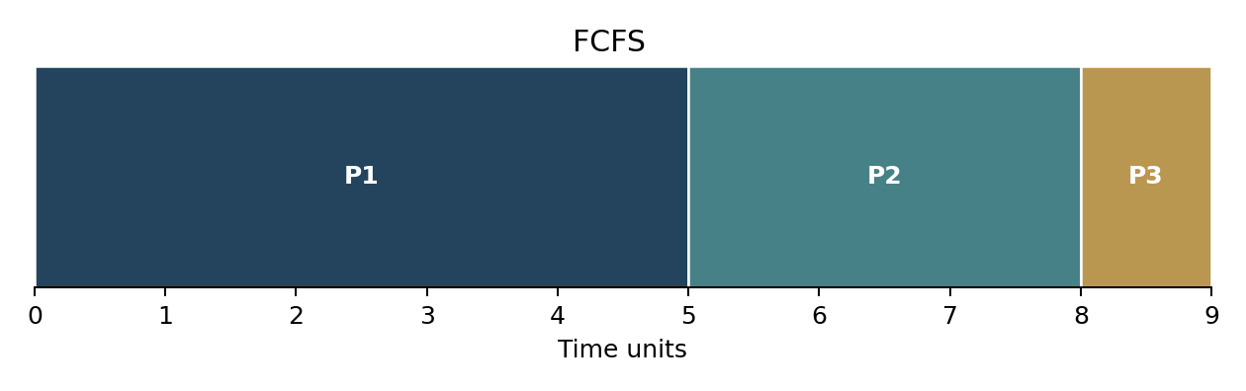
Figure 6 1 Recomputed FCFS timeline for the reference workload
Turnaround values are five, seven and seven. Waiting values are zero, four and six. Their means are 6.33 and 3.33 respectively when displayed to two places. For example P2 waits from its arrival at time one until its start at time five producing four waiting units.
These results follow directly from the non-preemptive model. The chart is generated for this report from the supplied implementation than being presented as a captured browser screenshot or a measurement from a real CPU.

6 3 Non preemptive SJF worked example
The same workload is used without changing arrivals or bursts. P1 is the ready process, at time zero so SJF cannot choose the future shorter jobs first. P1 completes at time five. Both P2 and P3 are then ready. P3 has the shorter burst. It runs from five to six after which P2 runs until time nine.
PID | Arrival | Burst | Completion | Turnaround | Waiting
P1 | 0 | 5 | 5 | 5 | 0
P2 | 1 | 3 | 9 | 8 | 5
P3 | 2 | 1 | 6 | 4 | 3
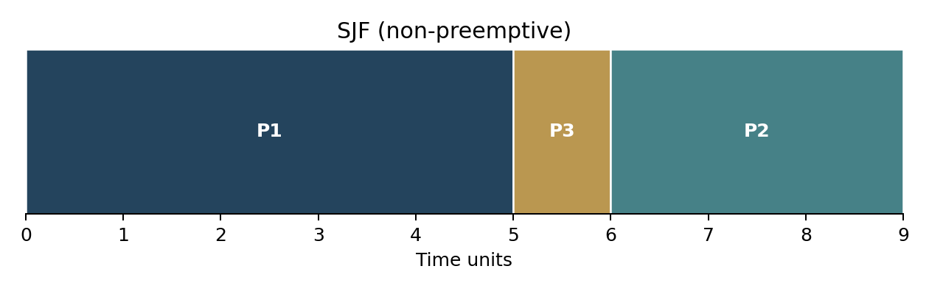

Figure 6 2 Recomputed non preemptive SJF timeline
The turnaround numbers are five, eight and four giving a mean of 5.67. The waiting numbers are zero, five and three giving a mean of 2.67. P2 waits longer than it does in FCFS while P3 finishes earlier. The overall improvement shown in this example comes with a spread of waiting times across the processes.
This example shows how the scheduler picks among jobs that're ready at the moment. It should not be turned into a claim that SJF always makes every single process better or that the prototype guesses burst times. The burst lengths are given as fixed classroom inputs.

6 4 Round Robin worked example
Round Robin uses a quantum of two for this example workload. P1 runs from time zero to time two. P2, which arrived at time one and P3, which arrived at time two join the queue before P1 is put back in line. The time slices are: P2 from two to four P3 from four to five P1 from five to seven P2 from seven to eight and P1 from eight to nine.
PID | Arrival | Burst | Completion | Turnaround | Waiting
P1 | 0 | 5 | 9 | 9 | 4
P2 | 1 | 3 | 8 | 7 | 4
P3 | 2 | 1 | 5 | 3 | 2

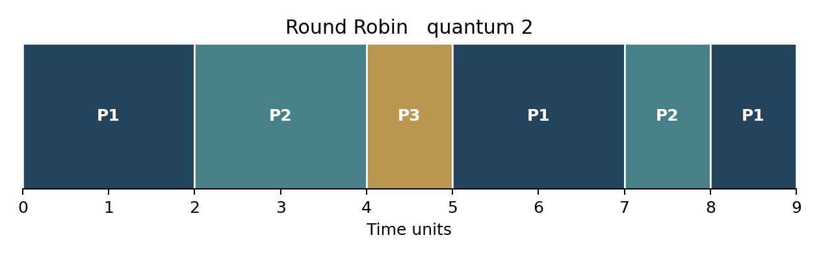

Figure 6 3 Recomputed Round Robin timeline with quantum two
P1 finishes at time nine P2 at time eight and P3 at time five. The turnaround numbers are nine, seven and three while the waiting numbers are four, four and two. The means are 6.33 for turnaround and 3.33 for waiting. The total CPU burst is still nine; changing the order moves the completion times. Does not add more work.
The fact that FCFS and Round Robin have the average waiting time on this workload does not mean their schedules are the same. Their individual time slices and turnaround numbers are different. This example helps show why an average alone does not fully describe a schedule.

6 5 Comparative interpretation of schedules
The comparison chart shows the numbers that were calculated earlier using the input processes and the same assumptions. Non-preemptive SJF has the mean waiting time and the smallest mean turnaround time for this particular set of jobs. FCFS and Round Robin share the means but give different results for each individual job. No real context-switch. I/O delay is counted.
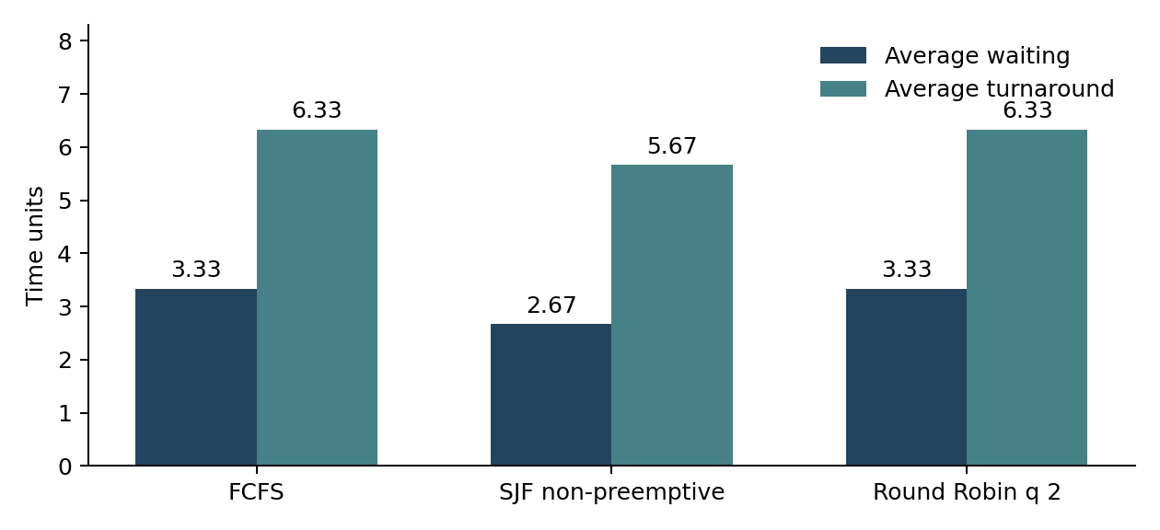 Figure 6 4 Average metrics for one workload
The picture is meant to teach, not to test real systems. The shapes of the arrival times the lengths of the bursts and the size of the quantum can change which average is higher. A larger study would look at different workloads and report both overall averages and job-level details separately.
The calculation tool lets you change one length one arrival time or one quantum and then see how the chart changes. For example if you cut P1’s burst from five to two while using FCFS the finish times become two, five and six. The mean waiting time becomes 1.33. This shows that the numbers depend on the input not on a fixed picture.
The program says that turnaround equals finish time minus arrival time and waiting equals turnaround minus length. Showing these formulas next to the table invites students to verify each row. The LLM explanation is help; the table and chart come from the Python scheduling code.

6 6 Boundary and validation cases
Edge cases matter because a demo with three normal jobs can hide mistakes in the queue logic. The provided function shows periods clearly keeps the original order when several jobs arrive at the same time and rejects any job that is not valid. The table below lists the cases that were checked separately or against the code.
Case | Input or condition | Expected behaviour
Initial idle period | P1 4 2 and P2 10 1 | Idle 0 to 4; both waiting times zero
Future short process | A 0 8 and B 1 1 with SJF | A runs first; B completes at 9
Zero burst | P1 0 0 | Rejected
Negative arrival | P1 minus 1 2 | Rejected
Duplicate PID | Two rows named P1 | Rejected
Missing column | PID and arrival only | Rejected
Nonpositive quantum | Quantum zero | Rejected
RR boundary arrival | P3 arrives at time 2 | P3 admitted before P1 requeue

The validation messages appear in the user interface without showing a wrong result table. When a student fixes an entry they can run the calculation again in the tab. The limits, on number of jobs and total time keep the chart easy to read even though many slices can still crowd the labels.
numeric controls are built for integer time units. The underlying function casts quantum to an integer so callers outside UI should validate input explicitly if they expose a broader API. Such implementation details should be considered before treating function as a scheduling service.
No test in this set models dispatch, priorities, dynamic process creation I/O bursts or scheduling overhead. The limitation is a property of the chosen teaching model, not a hidden failure to implement an operating system.

6 7 Backend regression results
The notebook contains a unittest suite with eleven test methods. For this report test source is. Executed against the uploaded core.py. Test methods use files and a fake generator where appropriate. Test methods do not require Qwen inference to verify service rules. All eleven test methods pass in this execution.
Test area | Checked behaviour
FCFS and SJF | Exact waiting and completion values
Round Robin | Completion values and boundary queue order
Idle and future arrivals | No premature execution
Invalid input | Malformed processes and zero quantum rejected
Ingestion rebuild | Changed content produces a new chunk identity
PDF and PPTX parsing | Source boundaries and text extraction
MCQ validation | Invalid source IDs rejected
Practice persistence | Attempts survive Tutor recreation
Duplicate grading | Second submission rejected
Abstention path | No generation call when evidence is empty

Eleven test methods include several assertions and scenarios so number of table rows is not a count of test methods. The successful result provides evidence for these deterministic behaviours. It does not establish live-model factuality, Chroma search quality, GPU compatibility or browser availability.
Live interface should therefore also be checked in the teams runtime. Retaining a screenshot of regression output is useful, for submission traceability while test source allows result to be reproduced after code changes.

6 8 Retrieval and answer review
The browser review starts with a question whose supporting page is known. A scheduling question should find scheduling content of an unrelated thread passage. The user then looks at the generated explanation. Compares it with the evidence panel and the original document. This checks coverage, source identity and factual support in steps.
Review case | What to inspect
Covered definition | Correct concept and relevant source
Algorithm comparison | Correct variant and preemption distinction
Missing topic | Appropriate insufficient-support behaviour
Unrelated request | No unsupported general-purpose response
Citation display | IDs correspond to supplied excerpts

A useful answer demonstration shows the actual application response, cited filename and page or slide number together. The example should be checked for correctness and source agreement. A useful figure caption identifies the question. Explains why the displayed passage supports the answer.
Formal Evidence Hit at k requires a labelled question set with expected source pages. The implementation provides an evaluation helper for that purpose. A formal labelled retrieval benchmark has not been created,. No numerical retrieval accuracy or latency benchmark is claimed here.
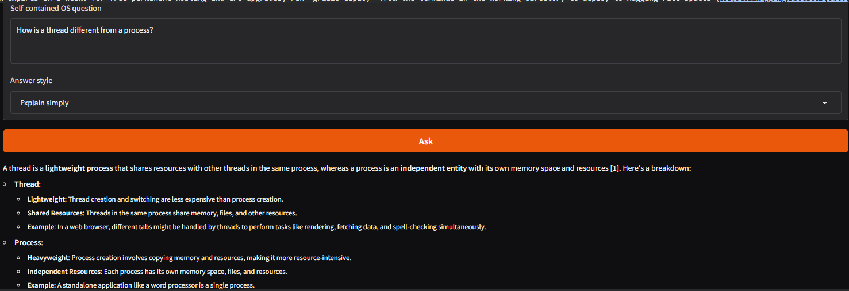
Figure 6 5 Course grounded answer

6 9 Practice and progress review
Practice review checks the full lifecycle instead of only the appearance of a question. A fresh pseudonym creates a covered-topic MCQ selects an option and gets feedback. The source IDs and explanation should be checked for agreement. Submitting the question again should give a duplicate-submission message without increasing the attempt count.
A known sequence of three submissions requests hard on the following question. Two correct of three requests. Than three attempts always requests easy. Rebuilding Tutor with the database confirms that the progress is stored outside browser memory. These are service rules; the actual conceptual difficulty of the generated wording still needs review.
The default pseudonym in the interface is convenient for a demonstration. Should be changed when testing separate learners. A students all-time percentage and recent requested difficulty summarize windows. Screenshots should therefore include the selected topic and pseudonym so that the displayed progression is clear.
The system does not provide examination delivery. A shared demonstration password and editable pseudonym are not enough for identity assurance. The value of this component is practice with transparent rules, not the automatic assignment of official marks.
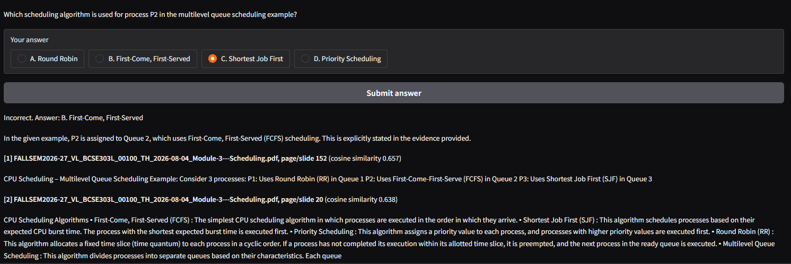
Figure 6 6 Practice feedback and saved progress

6 10 Discussion of outcomes and evidence
The architecture shows a coherent combination of document retrieval, language generation, practice state and deterministic computation. The code shows how a question moves through retrieval to a generation call and how the interface shows supporting passages. The calculator adds an OS interaction that can be checked without trusting generated arithmetic.
The strongest reproducible results are the scheduling outputs and backend test results. The implementation also contains controls for evidence malformed quizzes and duplicate grading. These support claims about software behavior. The teams reported successful interface run supports the demonstration while screenshots and saved outputs can make that observation independently reviewable.
The present evidence does not justify a percentage for answer accuracy a claim that hybrid retrieval's better on this corpus or a claim that adaptive questions improve student learning. Those questions require evaluations. Retrieval needs gold pages and held-out questions; factuality needs answer review; learning gains need a study. Combining these into one accuracy" would hide important differences.
Several design trade-offs are suitable for a course prototype. Direct library calls improve readability a small model reduces resource pressure a shared UI reduces deployment work. A simple difficulty rule is explainable. The cost is scalability, weak identity separation, potentially repeated questions and dependence on document extraction quality.
Overall the results support presenting OSTutorLLM as an implemented and demonstrable learning application with scheduling examples. They also provide a boundary for future experiments: improve the parts whose quality is currently assumed or checked manually and keep the deterministic checks that already make the system easier to assess.

7 Conclusions

7 1 Project conclusions
OSTutorLLM brings course-document retrieval, pretrained language-model inference, formative practice and a numerical OS laboratory into one browser application. The implementation keeps source metadata shows retrieved evidence and provides handling when no passage meets the relevance gate. These choices support an inspectable learning workflow than displaying an explanation without its context.
The scheduling component shows a contribution that is separate from language-model arithmetic. FCFS -preemptive SJF and Round Robin produce reproducible tables and execution charts under explicit assumptions. The regression suite checks backend rules, including duplicate grading, persistence and abstention control flow. The resulting prototype is suitable for explaining both AI integration and conventional algorithm design during a faculty review.
The project uses existing model weights. Does not claim completed fine-tuning, a new language architecture or measured learning improvements. Its practical contribution is the implemented integration and the separation of generated explanations from calculations. The limitations and future-work chapters identify the validation and deployment steps needed before classroom adoption.
Project repository
GitHub link: https://github.com/yuvanesh2024/OSTutorLLM

8 Limitations

8 1 Knowledge coverage and generation quality
The tutor can retrieve only what the active corpus contains. A menu topic may be available when no useful documents have been uploaded for it. Short definitions can be filtered out by the minimum word rule and visual relationships may be lost during text extraction. Image- PDFs, screenshots and diagrams require OCR or a manually checked transcript.
Fixed word windows do not guarantee a fixed length. Long technical identifiers can exceed the encoders input budget while overlapping windows can still split a concept across boundaries. Global semantic deduplication is missing repeated teaching material can occupy several retrieved slots. A source-aware chunk is traceable but not automatically complete or authoritative.
The hybrid ranker has an eligibility gate. Relevant lexical- passages outside the dense shortlist cannot be returned. The default similarity threshold is not calibrated on the course corpus and semantic similarity is not confidence. Unsupported questions can pass the gate while a valid question may be rejected. Citation-range checks cannot detect a fact that's unsupported by an otherwise valid source ID.
Language-model generation can produce incorrect explanations, repeated wording or truncated JSON. MCQ validation checks structure than whether exactly one answer is conceptually correct. The application also lacks conversation history so elliptical follow-up questions are not grounded using turns. These constraints mean the tutor should be used with source inspection and sampled review.
No formal answer-accuracy benchmark, curriculum-wide coverage analysis or learning-effectiveness study is established by the submitted template notebook. The visible interface and deterministic tests are evidence but they should not be used to claim outcomes that were not measured.

8 2 Runtime security and numerical scope
The current deployment depends on an active Colab runtime and a temporary Gradio tunnel. GPU quota, disconnection, network conditions and changing preinstalled packages can interrupt the service. Persistent source documents do not preserve a loaded GPU model. Restarting the application requires rebuilding runtime objects and possibly downloading model files again.
The practice database is intended for one controlled writer. Synchronizing a SQLite file through Drive is not a production concurrency design. The UI queue limits work and the model lock serializes generation but neither provides a measured classroom throughput guarantee. There is no production monitoring, structured service-level objective or automatic recovery manager.
The demonstration username and password're shared access controls, not individual identity. A pseudonym can be entered by another user and progress can therefore be confused or intentionally affected. Role-based faculty controls, session ownership and administrative audit trails are missing. Public deployment must also consider permissions, for teaching documents and retention of student records.
The numerical lab is deliberately restricted. It models one CPU, known integer bursts, no I/O blocking and no context-switch cost. It excludes SJF, priorities, multilevel queues and multicore scheduling. The chart can become crowded when small quanta create slices. These are teaching-model boundaries that must be stated when interpreting results.
Shell exercises are. Never executed by the application. This reduces execution risk. It also means the program does not automatically verify whether a generated script runs correctly. A separate disposable environment and instructor review are needed before adopting generated code as laboratory material.

9 Future Work

9 1 Retrieval and assessment improvements
The first extension should be a labelled evaluation set covering all modules. Questions should include answer pages, paraphrases, missing topics and unrelated requests. A development subset can tune the similarity gate while a held-out subset measures evidence hits and unsupported-question behavior. Answer correctness and citation support should be reviewed separately from retrieval.
Token-aware chunking can replace approximate word windows. Short neighboring slides could be combined when they share a title or topic while technical pages could be split at headings and sentences. OCR should be accompanied by review than treating recognized text as inherently correct. Corpus manifests could record module, document version and extraction method.
Retrieval experiments could compare only search BM25-only search, the current gated fusion and a candidate-union approach. A cross-encoder reranker may improve ordering. Its extra latency must be measured. Query expansion and topic metadata should be added only if they improve the defined evaluation set without degrading unsupported-question handling.
For MCQs the next improvement is a review and deduplication layer. It could compare question similarity verify option-answer consistency and allow a faculty member to approve items. Difficulty labels could be calibrated against student response data rather than relying only on prompt adjectives. Such data collection needs a consent and retention policy.
Fine-tuning must always be an experiment that starts with a baseline, not something added for looks. A selected instructional dataset and a separate test set would be necessary to check if the new weights make explanations better or questions more effective, than the current RAG system. The project must keep evidence retrieval even if tuning is added later.

9 2 Deployment and learning experience
Independent hosting can keep the app running when a personal Colab session ends. A ready-to-use service would load the models when it starts keep indexes that have version numbers, store progress in a storage that does not change and show health status. Before picking a hosting plan it is important to check the cost of GPUs how long it takes to start and how many users can use it at once. Just having a fixed URL does not mean the service will always be available.
Individual authentication and role-based access are required before we can save any student progress that can be identified. A faculty role can approve the source material check that questions are good and export progress while keeping personal data hidden. We must test backup. Restore steps and we must keep sensitive settings outside of the source code repository.
The learning interface might allow users to filter by module see which parts of a document are covered and use charts that can be read by everyone. A future chat feature should keep the source as a reference instead of adding an endless chat log. Students could get suggested follow-up questions that stand alone or links to the part of the source. We must test these ideas with learners to make sure they are clear.
The numerical lab can grow by adding SRTF, priority scheduling, page replacement or Banker-style exercises. Every new calculator should state its assumptions check that the inputs are correct and show a worked example before adding an explanation. This keeps the idea intact: precise algorithms give real numbers inside their model and the language model only helps explain those numbers.
A final research direction is to run a ethically sound learning study. We should measure students before the study have a comparison group and take measures after the task so we can talk about how students understand concepts, not just how they feel about the interface. Until we have that evidence the educational benefits are still goals, not proven results.

References
[1] P. Lewis et al. Retrieval Augmented Generation for Knowledge Intensive NLP Tasks. NeurIPS, 2020.
Https://arxiv.org/abs/2005.11401
[2] N.. I. Gurevych. Sentence BERT Sentence Embeddings using BERT Networks. EMNLP IJCNLP, 2019.
Https://aclanthology.org/D19-1410/
[3] W. Wang et al. MiniLM Deep Self Attention Distillation for Task Agnostic Compression of Pre Trained Transformers. 2020.
Https://arxiv.org/abs/2002.10957
[4] Sentence Transformers. All MiniLM L6 v2 model card. Online technical documentation.
Https://huggingface.co/sentence-transformers/all-MiniLM-L6-v2
[5] S. Robertson and H. Zaragoza. The Probabilistic Relevance Framework. Beyond.. Trends, in Information Retrieval vol. 3, No. 4 Pp. 333-389 2009.
Https://doi.org/10.1561/1500000019
[6] G. V. Cormack, C. L. A. Clarke and S. Buettcher. Reciprocal Rank Fusion outperforms Condorcet and individual Rank Learning Methods. SIGIR, pp. 758-759, 2009.
Https://doi.org/10.1145/1571941.1572114
[7] A. Yang et al. Qwen3 Technical Report. 2025.
Https://arxiv.org/abs/2505.09388

References continued
[8] Qwen Team. Qwen3 4B model card. Online technical documentation.
Https://huggingface.co/Qwen/Qwen3-4B
[9] Hugging Face. Transformers bitsandbytes quantization. Version 4.56.2 documentation.
Https://huggingface.co/docs/transformers/v4.56.2/quantization/bitsandbytes
[10] R. H. Arpaci Dusseau and A. C. Arpaci Dusseau. Operating Systems Three Easy Pieces. Online textbook.
Https://pages.cs.wisc.edu/~remzi/OSTEP/
[11] Chroma. Configure Collections. Online technical documentation.
Https://docs.trychroma.com/docs/collections/configure
[12] Gradio. Sharing Your App. Online technical documentation.
Https://www.gradio.app/guides/sharing-your-app
[13] SQLite. Transaction. Online technical documentation.
Https://www.sqlite.org/lang_transaction.html
[14] OSTutorLLM project team. Project implementation materials. Core.py ui.py, START_HERE.ipynb, GUIDE.md and requirements.txt.
GitHub URL to be added in the Conclusions chapter.

